# Colas TMA Financials Extract

No documentation but looking at the code this appears to extract some TMA data into CSV files every day at midnight, which are then FTP-d to a site for Colas to download for financial reports.

## 6 procedures:

* Do_ftp_from_os.sql
* Nsg_org_csv.sql
* Tma_phases_csv.sql
* Tma_streets_csv.sql
* Tma_works_csv.sql
* X_colas_financials_extract.sql

## 1 Function:

* Dump_csv.sql

## Metadata:

FTP Connection Types HIG0100

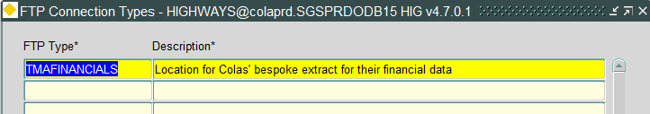

FTP Connections HIG0200

Password is currently set to Spuy2826. See list here: https://bentley.sharepoint.com/sites/AssetWise/FTP%20sites/New%20SunGard%20FTP%20Site.aspx

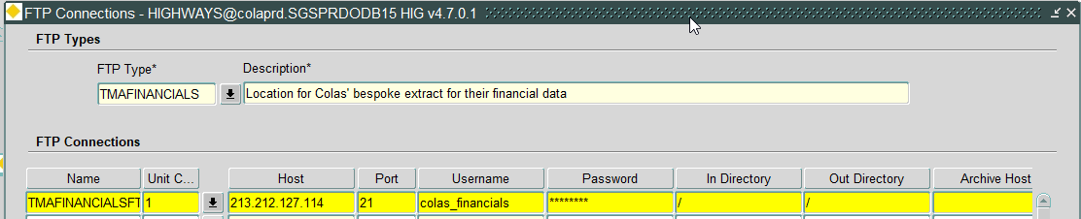

Directories HIG1895

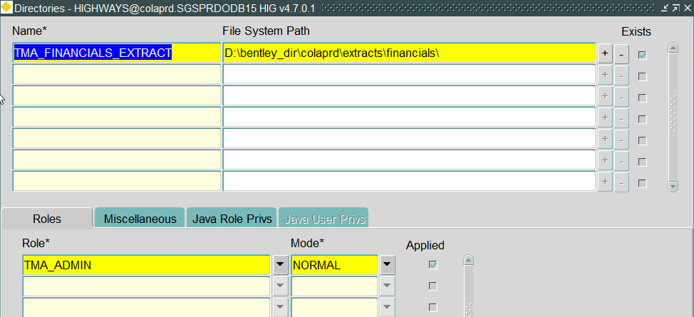

Process Types HIG2500

